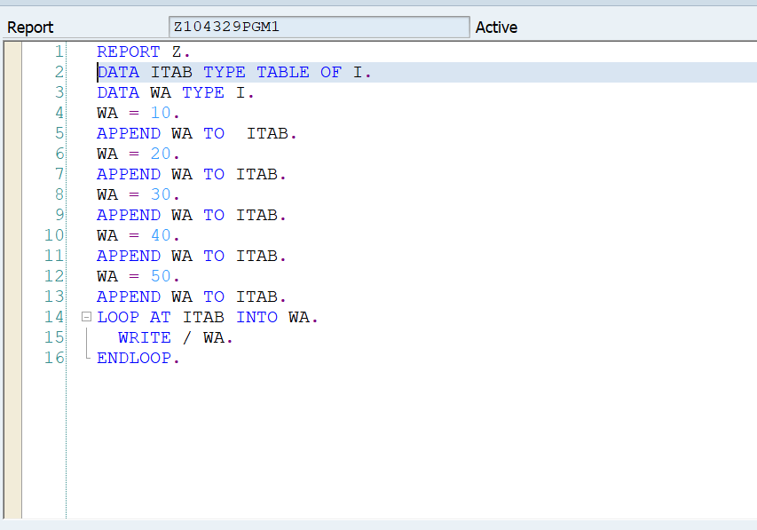

Go to program-execute-debugging

Select the Tab Desktop 3.

If you come across any statement which are not a part of your program , press F7 till you see first line of your program.

Double click on wa and itab so that you can watch the value of the varaibles.

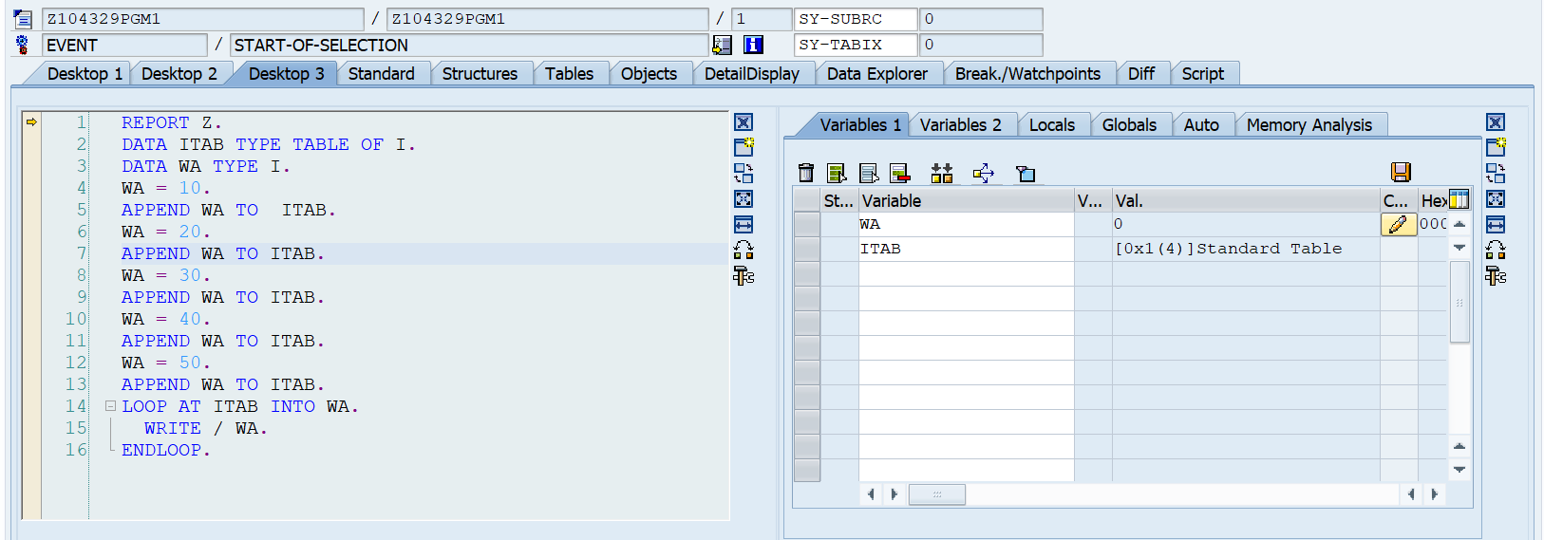

Press F5 to debug each line.

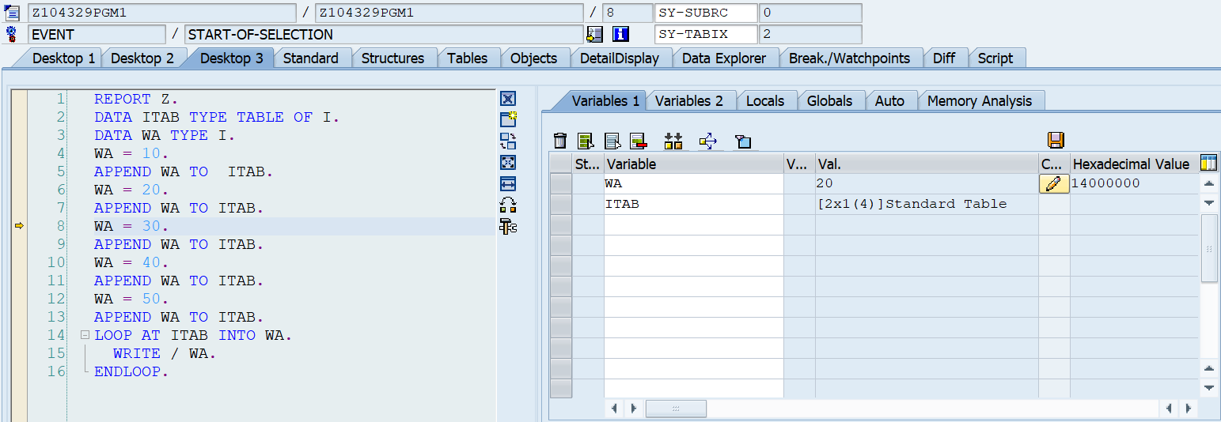

Click on tables tab. Enter name of table as itab. See the contents of table.

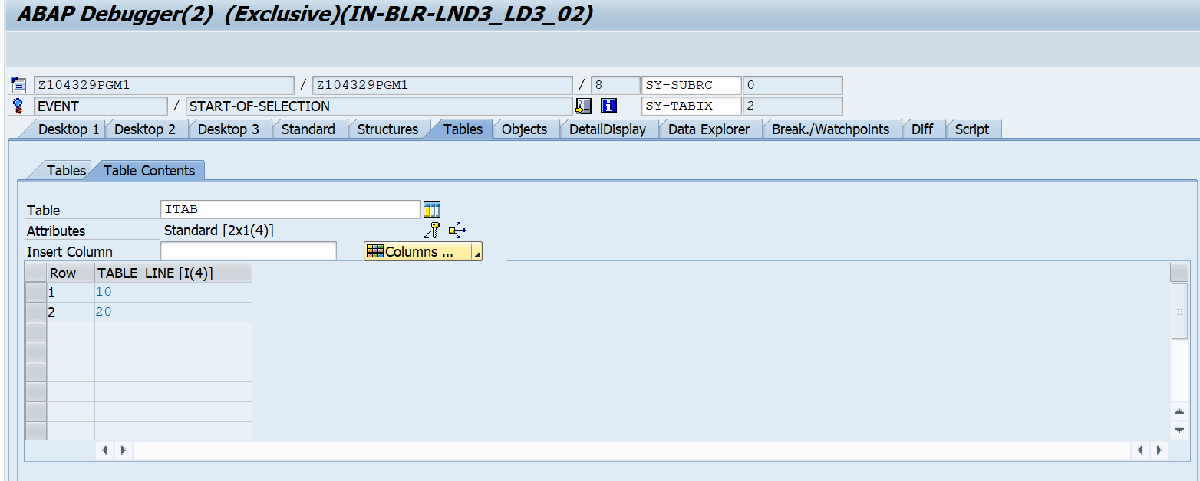

Click on Desktop 3 again.

Continue Debugging.

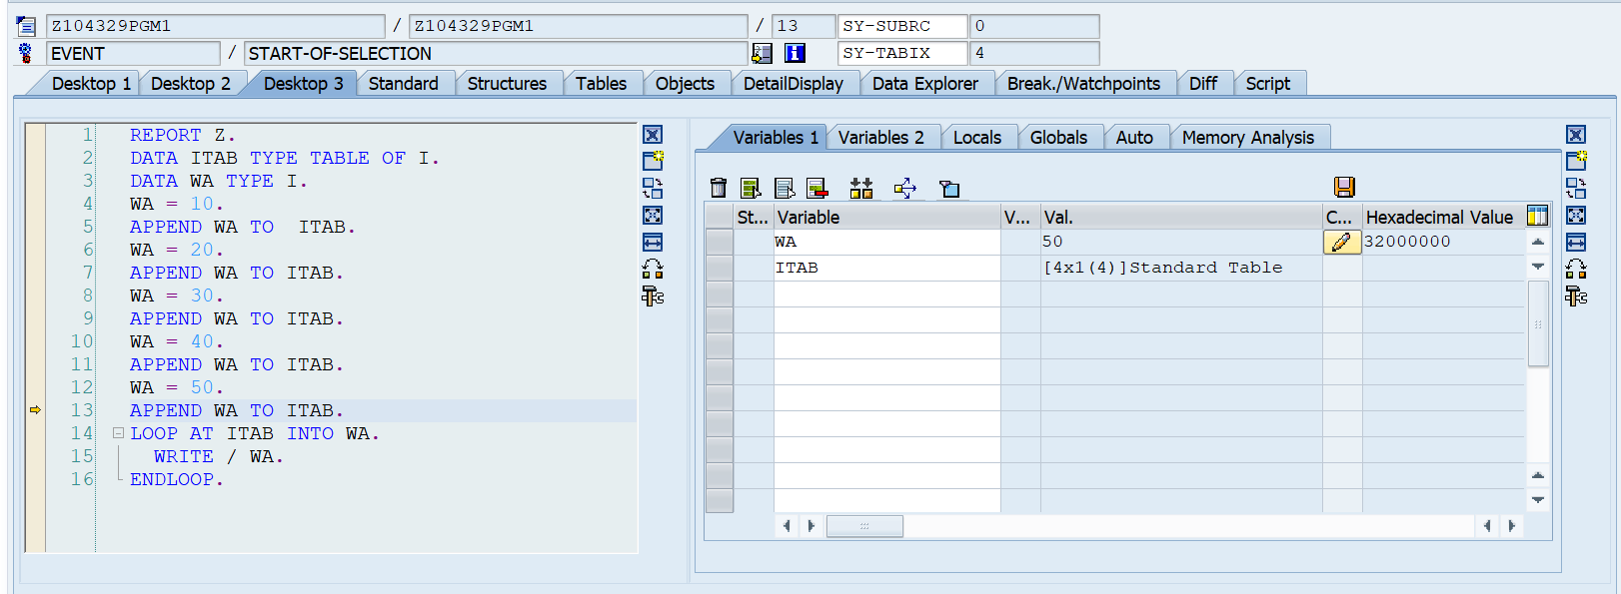

Continue Debugging to see how the loop statement works.

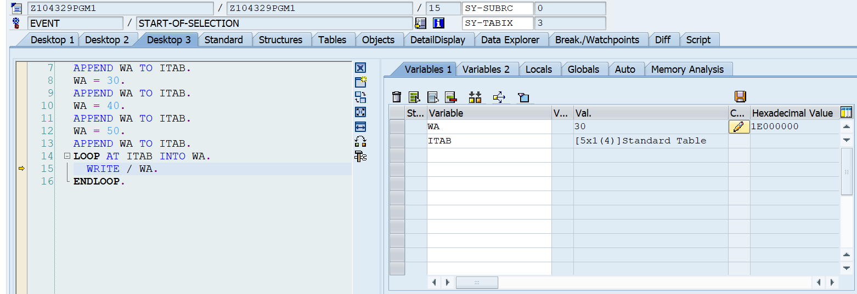

View the output.

Close debugger.